THE WORDS ACADEMY – www.thewordsacademy.com Prepared by Kevin
Say Hello to News. Name:………………………………….......... All Rights Reserved®

Notes -

Notes -


Notes -


Notes –


Notes –


Notes –


Notes -


Notes –


Notes –


Notes –

Features of a News Article.
- 5W and H
- Lead Sentence
- Formal Register
- Direct Quotations from (Experts, witnesses and victims)
- Appropriate and Catchy headline.
- Objective. No evaluations. No emotionally charged words.

5W and H and the Lead
What, where, when, who, why and How. These questions can get a lot of information. These things need to be addressed in a news article ideally. And usually, WHAT, WHERE, WHEN, WHO would be given in the first sentence or two. This is called the lead sentence of a news article. Why and How are rather difficult to include in the first sentence or two sometimes. That’s ok if it is not possible. The Lead sentence should not be unnecessarily cramped with information either. You can provide the How and the Why in the third sentence/paragraph or fourth.
Body
The body of the article would contain the specifics and the other important background details that are relevant to the news incident.
Direct quotations – These are really important as they give you first-hand information and perspectives of the people who are most qualified to give the information.
Witnesses /// Experts /// Victims >>> Remember though, that you need to select relevant and the most important things they say to include into your story. Quotations should be impactful.

Check out some examples on Headlines, Lead sentences and Use of quotations below.
(From http://newspaperarticleyear6.weebly.com/headlines-byline-lead-and-supporting-paragraphs.html)



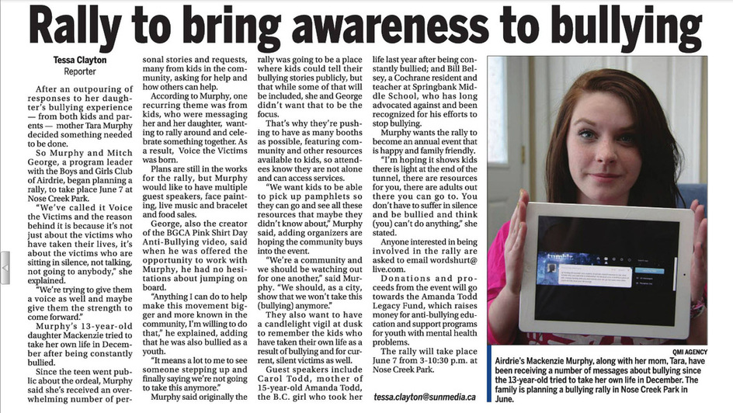
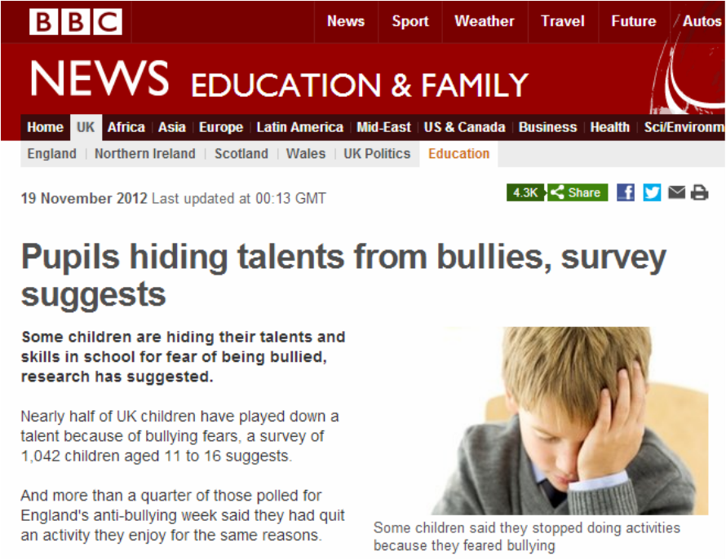


Task (From the Internet – Naqash Taqi - https://www.academia.edu/38220821/English_language_1123_Directed_writing_Topics_1_)

1. Recently a small child who was lost, was found wandering near a dangerous road and was rescued and taken back home safely by a stranger, who walked away without giving a name.
As a newspaper reporter, write your account of this incident which must include all the following:

• A suitable heading
• When and where the incident happened
• A brief description of the child
• How the stranger was able to help
• A request for the helpful stranger to contact the child’s parents by telephone

You may add further details but remember that newspapers do not have space for long, exciting stories. Your account should be a statement of the facts, in clear, correct English.
Write 250-300 words.

